EDUNET FOUNDATION-Class Exercise Notebook

LAB 2 – Registering a Raspberry PI on Cloud

Follow the below steps to register a device on Cloud.

Step 1. Clone the below repository on RaspberryPi
https://github.com/SoftwareAG/cumulocity-devicemanagement-docker-example.git
Step 2.. Open repository and note down the device id
cat cumulocity-devicemanagement-docker-example/Agents/config/config.ini
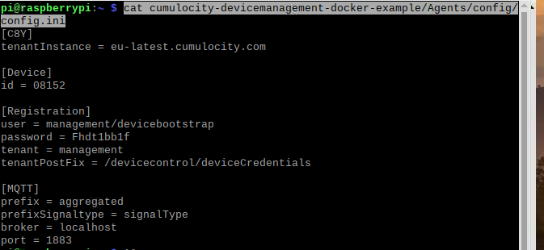

Step 3:-Then expand the 'Devices' tab in left-hand menu, go to 'Registration' and click 'Register device'.
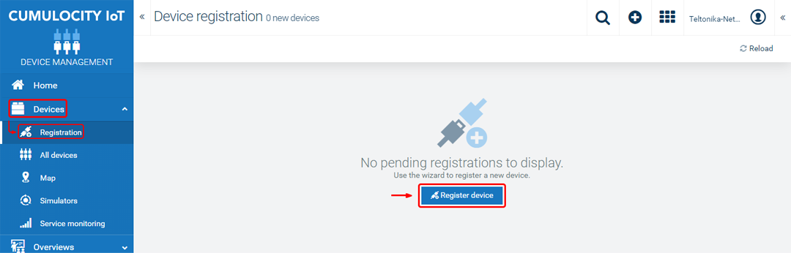

Step 4. Enter your device's serial number into the 'Device ID' field. Then it will await for device application to be turned on
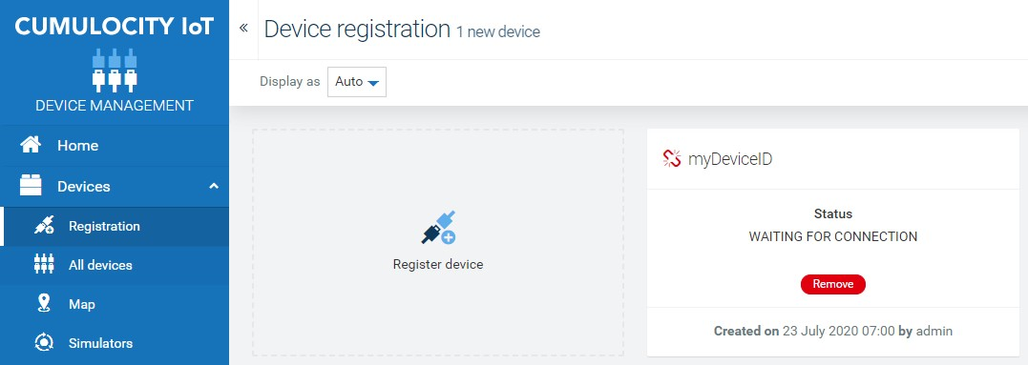

Step 5.. Run docker in Raspberry PI using below command to connect RPI to cloud
sudo bash cumulocity-devicemanagement-docker-example/start.sh

Step 6.. Refer back to dashboard to accept connection and now your device is connected to cloud.

